Reading for pleasure

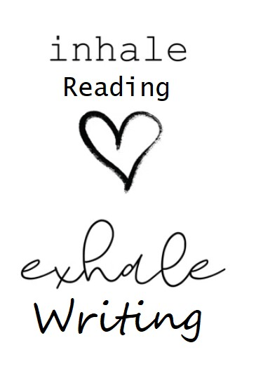

**‘*Books crowbar the world open for you.*’**(from ‘Rooftoppers’ by Katherine Rundell)

At Twineham, we are passionate about providing all of our children with a broad range of reading resources, memorable experiences and the highest quality reading teaching and encourage each one of them to become lifelong readers.

**Reading the key to unlocking a child's potential**

Twineham School.

Through hearing stories, children are exposed to a wide range of words and our teachers are passionate to provide as many of these experiences throughout school life. This helps them build their own vocabulary and improve their understanding when they listen, which is vital as they start to read and explore the world around them.

***‘Researchers in the United States who had looked at the impact of parents reading with their children quoted the following figures in a news release about their findings:***

***Here’s how many words kids would have heard by the time they were 5 years old:***

***Never read to, 4,662 words;***

***1–2 times per week, 63,570 words;***

***3–5 times per week, 169,520 words; daily, 296,660 words;***

***and five books a day, 1,483,300 words.’***

The Reading Framework 2023

We believe you are never too young to make a difference, and what better way to start learning how than to explore as many books as possible, cover to cover, as we begin to write our own story one page at a time!

**‘Reading for pleasure is the single most important indicator of a child’s future success.’  
OECD 2002**

10 minutes could change everything <https://www.youtube.com/watch?v=g4Nf0Hcuv4Y>

Top tips for reading with your child: <https://wordsforlife.org.uk/parent-support/reading-yourchild/#:~:text=Find%20a%20short%20slot%20in,have%20each%20other's%20full%20attention>.